MVLU College (Mumbai University)

Information Technology

Research Proposal

AI in Medical Domain
-- Research on COVID-19 disease prediction machine --

Student Name: | Shaikh Abdullah Khawaja
Studies | A.I (Artificial Intelligence)
Semester | Sem 5
Student ID | TY30
E-Mail | abdullah042973@gmail.com
Professor | Shivanya Kadam

Abstract
This paper refers to machine learning in the medical domain. the idea is to create the best fit models(algorithm) using supervised machine learning technology that trains on given datasets and predicts the outcome probability or result. Then compare the accuracy, loss, and optimization of all trained models.

Introduction
SARS-CoV-2 (COVID-19) was first officially detected in Wuhan, China in December 2019 and has set off a global pandemic. In this paper, I am going to research on COVID-19 disease prediction model with help of machine learning technology that predicts novel coronavirus using a trained model. Research paper divided into five-part (1) collecting raw data, (2) data pre-processing, (3) EDA (exploratory data analysis), (4) data visualization, (5) training and testing, (6) Result and conclusion.

Research Flowchart Diagram
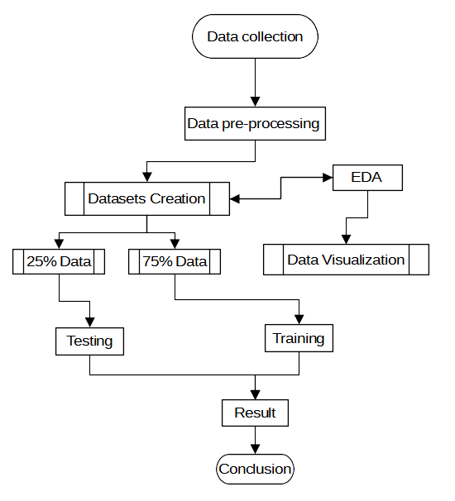

Technology used
- Hardware
    - Processor: AMD Ryzen 3 3200g,
    - RAM: 8Gb 3000Mhz,
    - Memory: 250Gb NV Me SSD.
    - GPU: Tesla T4 12gb 1.8TFlops
    - TPU: 8cores, 64worker (Thread) TPU (TensorFlow Processing Unit) with 180TFlop
- Software
    - Operating System: Windows 10,
    - Language: Python 3.0 or Higher,
    - IDE: Jupyter Notebook, Google colab, Python IDLE, Python shell
    - CUDA Version 11.2
    - Web Browser: Mozilla Firefox, Brave, Crome, Edge
    - Python Library: Pandas, NumPy, Seaborn, Matplotlib, Keras, TensorFlow, D-tale, Scikit Learn.
- Technique
    - Decision Tree
    - Ensemble
    - Neural Networks
    - Deep Learning
    - Transfer Learning.
- Algorithms
    - Random Forest,
    - Ada-boost,
    - Classification and regression Tree (CART),
    - Support vector classifier (SVC),
    - Logistic regression,
    - Navie Bayes,
    - Multiple linear regression,
    - Convolutional neural network,
    - Convolutional neural network with SVM (Hybrid CNN),
    - Back-Propagation,
    - Vgg16 (Transfer learning),

Future scope
This paper helps us to see how the AI (Artificial Intelligence) deals with real-life problems in the medical domain. As you know viruses transmit from one another and it will take 6 to 7 days for symptoms to appear. There are three stages in COVID-19 Low, Moderate, and Critical In the beginning stage it's hard to recognize COVID-19 patience but with help of AI (Artificial Intelligence), we can predict the outcome probability by using a patient's X-ray, CT-scan, and some common features (symptoms). This research is for learning purposes only.

